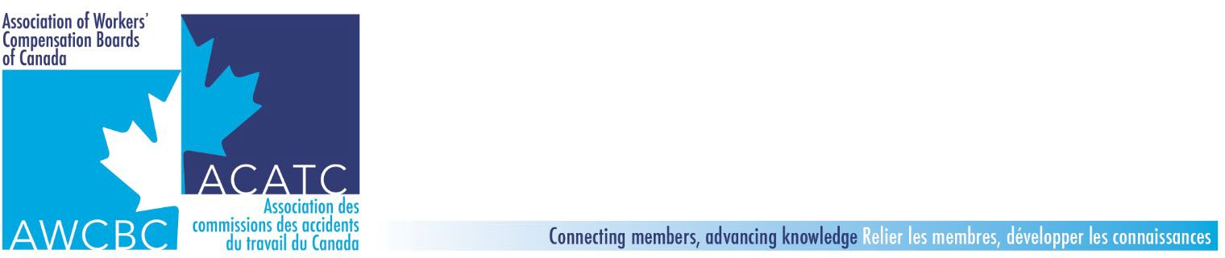 **Meeting Minutes**

**Financial and Statistical Data Comparability Committee & WCB CFOs**

**December 5, 2022 (1 pm – 3 pm AST)**

[Virtual Meeting (Microsoft Teams)](https://teams.microsoft.com/l/meetup-join/19%3ameeting_OGJlYThkOTktMGE2Ni00YWYyLTkwMjgtMzE4OWExYWIwMmM2%40thread.v2/0?context=%7b%22Tid%22%3a%22f92be3a4-bf2b-4d5d-a99a-51a39c5226c2%22%2c%22Oid%22%3a%22ec6a35d1-eccb-489f-b1cf-21c0f131215b%22%7d)

**Attendees:** Jilal Jemal, Andrew Vavasour, Maureen Boyd, Crystal Nett, Al Taylor, Harry Cassie, Mark Heywood, Jim Stephens, Maureen Thomson, Julie Beausoleil, Anne St-Martin, Laurent Charron, Leslie Anne Hurley, Perry Cheek, Mike Freeze, Guillaume Baril, Lee Thaddeus, Thomas Webb, Ty Gillies.

**Welcome, Introductions Financial Update**

1. Brief introduction of attendees. Attendees from all jurisdictions “WCBs”; exceptions Ontario and PEI as unable to attend.
2. 2022 – Financial update discussion focused on:

* Most WCBs experiencing investment declines YTD.
* Decline YTD Funded %; ranges 6% – 27%; primarily investments, increasing claims pressures; premium distributions/changes.
* Discussion of discount rate – and about 7 are either increasing discount rate or watching; 3 firmly no change contemplated.

**IFRS 17 Update**

1. Al Taylor – Chair of the WCBs Directors working Group provided an update on IFRS survey results and discussions. Areas highlighted included:
   * Discussion of annuities where majority of boards currently do and will continue to include annuities in the benefits liabilities therefore applying IFRS 17. Exception is BC that does not include in benefits liabilities now, and therefore will continue to apply IFRS 9 to measure.
   * Onerous contracts measurement date when rate is set or January 1 of policy year. Nine jurisdictions will or are leaning to January 1 – based on Act allows, or nothing in Act doesn’t allow and recognize that Board may set rate but could change it if they had to before the calendar year starts. Three boards will measure when rates announced (BC, AB, ON) based on their Act or analysis.
2. General discussion on readiness for 2023 implementation and impact on discount rate under IFRS 4 and 17 conversing. NS and BC noted that they will be ready for January 1 opening balance audits in the first half of 2023.
3. Update from the communications subgroup. Crystal shared an update that the group has met and prepared a framework and guiding principles. In addition, they had a presentation to share, and it was agreed to organize a meeting in January dedicated to this topic.

**Key Statistical Measures (KSM) Indicators**

1. General discussion on history of this committee evolution to have share consistent KSMs captured for all WCBs in one location. Noted that to date for 2021 only 6 jurisdictions have posted the KSMs. Encouraged other to update the AWCBC website.
2. Follow up on previous meetings where the IFRS 17 impact on KSMs were reviewed. Preliminary thoughts were that AWCBC website could continue to use IFRS 4 standards. Suggested that with some time and further understanding of IFRS 17 impact, a smaller statistical working group consider this further and consider connection of communication messages and audited information versus unaudited. Will look for volunteers.
3. Jilal shared an update on the AWCBC Website project for online data usage and noted overall opportunity to modernize and that there is a plan to initiate an RFP to support this work.

**Actions**

1. Meeting in January for Saskatchewan to share Communications presentation and general discussion. Jilal to canvas for date and invite the AWCBC communications co-chairs.
2. Jilal to send out a request to the group to confirm who is currently on the KSM subgroup and others who may want to join giving change in teams. Future opportunities to look at relevance of the KSMs (IFRS 4 or 17 – further consideration to what is publicly available; too many KSMs? Which ones are being used)?