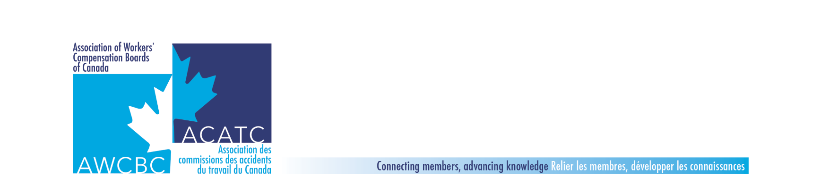

**Compensation & Benefits Committee - AWCBC Jurisdictional Update Report**

|  |  |  |
| --- | --- | --- |
| **Committee Member:** (add name) | **From:** (add jurisdiction here) | **Date:** May 2020 |

|  |  |
| --- | --- |
| Mandate | *Defines expectations / responsibilities. Facilitates better focus on objectives and activities by which the committee operates*. |
| The AWCBC Compensation & Benefits Committee works collaboratively to share experiences, identify and improve claim-related outcomes and identify and action opportunities around operational, research and policy development initiatives. | |

|  |  |  |
| --- | --- | --- |
| Goals | *Based on your mandate, set realistic and specific goals. What is the long-range aim? What do you hope to achieve?* | |
| 1. To share jurisdictional experiences and knowledge. | |  |
| 1. To put before the committee, emerging issues that are deemed high priority, for consideration of planning | | |
| 1. To identify, plan, and carry out specific projects for the benefit of the committee members and their respective jurisdictions. | | |
| 1. To be available to other AWCBC / national committees to provide input and or partner with when requested. | | |
| 1. To provide feedback to AWCBC Executive when required or requested. | | |

|  |  |  |  |
| --- | --- | --- | --- |
| Return to Work Outcomes | | | |
| Objectives *Improving Return to Work Outcomes/Reducing Durations (Share work that is being done within your organization to support RTW, reduce duration etc)*   1. Organizational Changes to support RTW 2. New Initiatives 3. Best Practices 4. Outcomes | Activities | Target Date(s) / Status | Budget |
| Vocational Rehabilitation | Have there been any organizational changes / new developments relating to vocational rehabilitation? | **All** |  |
| Medical Marijuana   * Ongoing discussions | Provide an update on any new developments relating to approval of cannabis | **All** |  |
| Opioids   * Strategies used by jurisdictions to reduce opioid use | Provide an update on any new developments relating to strategies to reduce opioid use | **All** |  |
| Worker Care Clinic Pilot | Manitoba to provide an update on this pilot | **Nancy Harley** |  |
| Health Industry Initiatives   * All jurisdictions to provide an update on initiatives to manage the challenges in the Health Care Industry | * Update on strategies for prevention and return to work in the health care industry | **All** |  |
| Fall Meeting | * Discuss topics for the Fall 2020 meetings in Newfoundland | **All** |  |
| Service Delivery/Quality Initiatives | | | |
| Objectives  *Service Delivery/Quality Initiatives*  *Share what is being done in your organization to improve Customer service delivery and to support Quality service/decisions to stakeholders.*   1. New Initiatives 2. Best Practices 3. Outcomes | Activities | Target Date(s) / Status | Budget |
| What is being done to improve customer service.   * New initiatives * Best practices * Outcomes |  | **All** |  |
| Customer/Client Service Training |  | **All** |  |
|  |  |  |  |
|  |  |  |  |
|  |  |  |  |
| Human Resources/Training | | | |
| Objectives *Human Resources/Training*  *Share information on staff related issues including training, recruitment, management oversight etc..*   1. Staffing Issues 2. New Initiatives 3. Training | Activities | Target Date(s) / Status | Budget |
| Recruitment | What education and experience do you require for key decision making positions such as adjudication and case management? Have you experienced challenges recruiting for these positions? If so, how are you addressing these challenges? Does your jurisdiction use float resources. If so, has this been successful? | **All** |  |
| Internal Training | Provide information concerning the orientation and training for new case managers. How do you evaluate the success of the training?  Provide information concerning any resiliency training opportunities provided to staff | **All** |  |
| New Initiatives |  | **All** |  |
|  |  |  |  |
|  |  |  |  |
|  |  |  |  |

|  |  |  |  |
| --- | --- | --- | --- |
| Emerging issues/Changes in Policy or Legislation | | | |
| Objectives *Emerging Issues/Changes in policy or Legislation*   1. Share information that is related to changes in legislation, policy and other significant changes within your organization | Activities | Target Date(s) / Status | Budget |
| Medical Marijuana   * anything legislative or policy related to be updated here |  | **All** |  |
| Psychological Injuries   * Chronic pain, workplace stress, PTSD and psychological overlay * Anything legislative or policy related to be updated here * Update on your jurisdictions’ approach to the management of psychological injury claims * Is there any collaboration between your claims and prevention areas on this topic? If so, please provide details. |  | **All** |  |
| Psychological Injuries | WSIB Overview: Mental Stress Injuries | **Sal Cavaricci and Julie Thurlow, WSIB** |  |
| Mental Health | Joint Meeting with AWCBC Safety and Prevention Committee | **Jamie Hall, Chair of AWCBC Safety and Prevention Committee** |  |
| Any changes in policy |  | **All** |  |
| Any changes in legislation |  | **All** |  |
| Update of whether there are any ongoing reviews of your legislation or of the worker’s compensation system in your jurisdiction. |  | **All** |  |
| Any changes that will impact the organization |  | **All** |  |
| Other Topics/issues happening in the jurisdiction  that would be of interest nationally | | | |
| Objectives | Activities | Target Date(s) / Status | Budget |
|  |  |  |  |
| Analysis of Jurisdictional Comparison of Noise Induced Hearing Loss | Update on Subcommittee Activities on Noise Induced Hearing Loss | **Sherry** |  |
| GECA/negotiations with the federal government | Anything new to report | **All** |  |
| Committee Structure   * Format * Structure * Chair/Co Chair succession plans * Terms of reference | We will do a quick review of the TOR and naming of co-chair for 2020/2021. | **Sherry** |  |
|  |  |  |  |
|  |  |  |  |
|  |  |  |  |

|  |  |  |  |
| --- | --- | --- | --- |
| KPI’s | | | |
| Objectives: *reporting KPI outcomes*   * Time to initial payment * Short term duration * Long term duration * RTW outcomes | Activities | Target Date(s) / Status | Budget |
| Time to Initial Payment |  | **All** |  |
| Short term duration |  | **All** |  |
| Long term duration |  | **All** |  |
| Return to work outcomes |  | **All** |  |
| Any other KPI’s that would be of interest | Discussion on whether these current KPIs are still relevant and if there are others we should include in the jurisdictional updates. | **All** |  |
|  |  |  |  |
|  |  |  |  |

|  |  |  |  |
| --- | --- | --- | --- |
| Technological Updates | | | |
| Objectives: *What is new/upcoming in the jurisdiction that will be of national interest.*   * Share information | Activities | Target Date(s) / Status | Budget |
| Case Management Systems   * + Learning from the case management models   Lessons learned  Pros and cons  Dashboards |  | **All** |  |
| Update on online services for clients and service providers |  | **All** |  |
| Portals and On-line Access | Julie to provide an update of their on-line services in Quebec | **Julie** **Courville** |  |
| Other Technological initiatives |  | **All** |  |
|  |  |  |  |
|  |  |  |  |