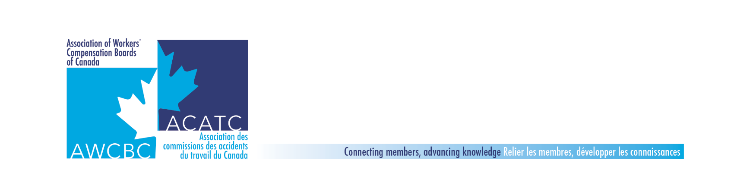

**Compensation & Benefits Committee - AWCBC Jurisdictional Update Report**

|  |  |  |
| --- | --- | --- |
| **Committee Member:** (add name) | **From:** (add jurisdiction here) | **Date:** May 2019 |

|  |  |
| --- | --- |
| Mandate | *Defines expectations / responsibilities. Facilitates better focus on objectives and activities by which the committee operates*. |
| The AWCBC Compensation & Benefits Committee works collaboratively to share experiences, identify and improve claim-related outcomes and identify and action opportunities around operational, research and policy development initiatives. | |

|  |  |  |
| --- | --- | --- |
| Goals | *Based on your mandate, set realistic and specific goals. What is the long-range aim? What do you hope to achieve?* | |
| 1. To share jurisdictional experiences and knowledge. | |  |
| 1. To put before the committee, emerging issues that are deemed high priority, for consideration of planning | | |
| 1. To identify, plan, and carry out specific projects for the benefit of the committee members and their respective jurisdictions. | | |
| 1. To be available to other AWCBC / national committees to provide input and or partner with when requested. | | |
| 1. To provide feedback to AWCBC Executive when required or requested. | | |

|  |  |  |  |
| --- | --- | --- | --- |
| Return to Work Outcomes | | | |
| Objectives *Improving Return to Work Outcomes/Reducing Durations (Share work that is being done within your organization to support RTW, reduce duration etc)*   1. Organizational Changes to support RTW 2. New Initiatives 3. Best Practices 4. Outcomes | Activities | Target Date(s) / Status | Budget |
| Vocational Rehabilitation   * Job Development – What services do you provide to ensure workers find employment? | Do you have a job bank of positions that are available to injured workers?  What incentives do you provide employers to hire injured workers?  (for example: salary support, ergonomic assessments, OT support, equipment purchases, etc) | **All** |  |
| Medical Marijuana   * Ongoing discussions | Provide an update on any new developments relating to approval of cannabis | **All** |  |
| Employee Resilience | PEI to present on their utilization of TEND Academy  Yukon to present on their approach to dealing with staff burnout | **Kate**  **Susanne** |  |
| Opioids   * Strategies used by jurisdictions to reduce opioid use |  | **All** |  |
| Hearing Loss | Ontario audiologist to present on Noise Induced Hearing Loss | **Christina Lopes** |  |
| Health Industry Initiatives   * All jurisdictions to provide an update on initiatives to manage the challenges in the Health Care Industry | * Psychological impact – violent injuries – are you seeing trends in injury types? * Return to work strategies for health care claims. * Any strategies for violent injury claims * For jurisdictions with the Prevention mandate, what are your strategies for preventing injuries | **All** |  |
| Fall Meeting | * Discussion of host province and topics to include in the Fall 2019 meeting | **All** |  |
|  |  |  |  |
|  |  |  |  |
|  |  |  |  |

|  |  |  |  |
| --- | --- | --- | --- |
| Service Delivery/Quality Initiatives | | | |
| Objectives  *Service Delivery/Quality Initiatives*  *Share what is being done in your organization to improve Customer service delivery and to support Quality service/decisions to stakeholders.*   1. New Initiatives 2. Best Practices 3. Outcomes | Activities | Target Date(s) / Status | Budget |
| What is being done to improve customer service.   * New initiatives * Best practices * outcomes |  | **All** |  |
| Customer/Client Service Training |  | **All** |  |
|  |  |  |  |
|  |  |  |  |
|  |  |  |  |
|  |  |  |  |

|  |  |  |  |
| --- | --- | --- | --- |
| Human Resources/Training | | | |
| Objectives *Human Resources/Training*  *Share information on staff related issues including training, recruitment, management oversight etc..*   1. Staffing Issues 2. New Initiatives 3. Training | Activities | Target Date(s) / Status | Budget |
| Internal Training   * Internal Training – Jurisdictions to review and provide the committee with information around inter jurisdictional training opportunities. Ie: staff attending training sessions offered by other jurisdictions, train the trainer opportunities, etc. |  | **All** |  |
|  |  |  |  |
|  |  |  |  |
|  |  |  |  |
|  |  |  |  |
|  |  |  |  |

|  |  |  |  |
| --- | --- | --- | --- |
| Emerging issues/Changes in Policy or Legislation | | | |
| Objectives *Emerging Issues/Changes in policy or Legislation*   1. Share information that is related to changes in legislation, policy and other significant changes within your organization | Activities | Target Date(s) / Status | Budget |
| Medical Marijuana   * anything legislative or policy related to be updated here |  | **All** |  |
| Any changes in policy |  | **All** |  |
| Any changes in legislation |  | **All** |  |
| Any changes that will impact the organization |  | **All** |  |
|  |  |  |  |
|  |  |  |  |
|  |  |  |  |
|  |  |  |  |
|  |  |  |  |

|  |  |  |  |
| --- | --- | --- | --- |
| Other Topics/issues happening in the jurisdiction  that would be of interest nationally | | | |
| Objectives | Activities | Target Date(s) / Status | Budget |
| Committee Structure   * Format * Structure * Chair/Co Chair succession plans * Terms of reference * Orientation guide | We will do a quick review of the TOR and selection of a co-chair | **Wade** |  |
|  |  |  |  |
|  |  |  |  |
|  |  |  |  |
|  |  |  |  |
|  |  |  |  |

|  |  |  |  |
| --- | --- | --- | --- |
| KPI’s | | | |
| Objectives: *reporting KPI outcomes*   * Time to initial payment * Short term duration * Long term duration * RTW outcomes | Activities | Target Date(s) / Status | Budget |
| Time to Initial Payment |  | **All** |  |
| Short term duration |  | **All** |  |
| Long term duration |  | **All** |  |
| Return to work outcomes |  | **All** |  |
| Any other KPI’s that would be of interest | Discussion on whether these current KPIs are still relevant and if there are others we should include in the jurisdictional updates. For example, the number and percentage of injured workers who are placed on long term earnings loss benefits on an annual basis.  (For Nova Scotia, we placed 426 workers on long term benefits in 2018. Our annual time loss claim volume for the past 5 years has averaged 5900 TL claims, so on average 7.2% of our annual time loss claim volume ended up on long term benefits in 2018). | **All** |  |
|  |  |  |  |
|  |  |  |  |

|  |  |  |  |
| --- | --- | --- | --- |
| Technological Updates | | | |
| Objectives: *What is new/upcoming in the jurisdiction that will be of national interest.*   * Share information | Activities | Target Date(s) / Status | Budget |
| Case Management Systems   * + Learning from the case management models   Lessons learned  Pros and cons  Dashboards |  | **All** |  |
| Update on online services for clients and service providers |  | **All** |  |
| Other Technological initiatives |  | **All** |  |
|  |  |  |  |
|  |  |  |  |
|  |  |  |  |
|  |  |  |  |