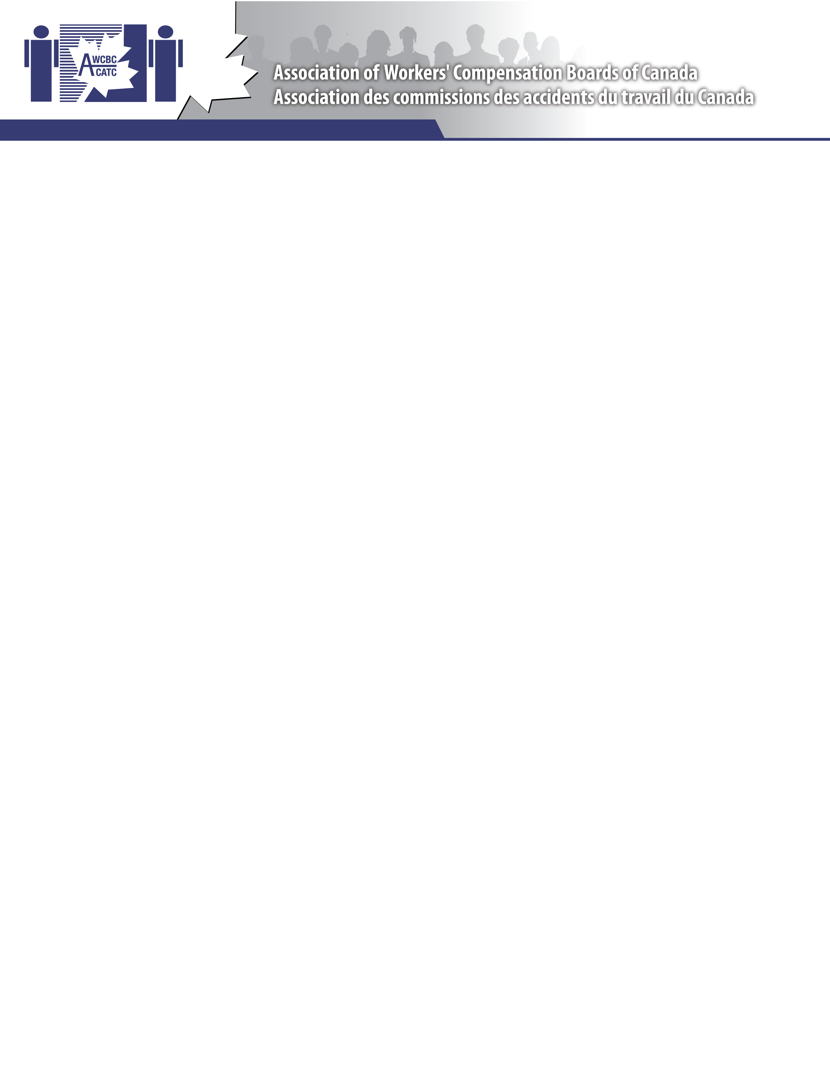

Jurisdictional Update Report

Date: April 30-May 1, 2014

To: Compensation and Benefits Committee From: New Brunswick

Committee Member: Barbara Keir

Committee Mandate
The AWCBC Compensation & Benefits Committee works collaboratively to share experiences, identify and improve claim-related outcomes and identify and action opportunities around operational, research and policy development initiatives.
Goals
- To share jurisdictional experiences and knowledge
2. To put before the committee, emerging issues that are deemed high priority, for consideration of planning
3. To identify, plan, and carry out specific projects for the benefit of the committee members and their respective jurisdictions.
4. To be available to other AWCBC / national committees to provide input and or partner with when requested.
5. To provide feedback to AWCBC Executive when required or requested.

Objective | Activities | Target Date(s)  /Status | Budget
Improving Return to Work Outcomes/Reducing Durations
(Share work that is being done within your organization to support RTW , reduce duration etc. )

- Organizational Changes to support RTW
- New Initiatives  Modified RTW | Starting in 2013, no lost time claimants who are on modified RTW are being transferred to Case Management at week 4. This early referral (historically, they were referred at week 12) is in response to employer requests to provide services to assist timely return to regular duties. Results demonstrate claimants are returning to regular duties more timely, decreased time on claim, and decreased percentage of claims becoming lost time.
Mild Traumatic Brain Injury (MTBI) | WorkSafeNB has developed a 2-step adjudication process for possible concussions / mild traumatic brain injuries (MTBI). This 2-step process will allow the adjudicators to make the initial determination that an injury involving the head did in fact occur in order to accept the claim (for a soft tissue injury to the head, head laceration, head contusion, etc.) and allow benefits to be issued. If the injured worker continues to be disabled from the injury (lost time, modified duties, or ongoing medical appointments / investigations), the claim is then transferred to a case manager. The potentially more complex decision regarding if there is in fact objective medical evidence to support that the injured worker did in fact sustain a concussion or MTBI is then carried out by the Case Management Team. Once the second stage of adjudication is completed (may require further medical assessments and medical symptom testing to be carried out), the injured worker will be notified of the decision and the claim will continue to be managed accordingly. See attached algorithm.
- Best Practices  Improving RTW Outcomes  WorkSafeNB – Return to Work Goal – We will decrease the time by which injured workers safety return or are ready to safely return to employment.  Strategy – Advancing and implementing leading practices in medical rehabilitation  Initiative – Traumatic Psychological Injury Continuum of Care | Implemented a Traumatic Psychological Injury Program in 2011-2012 consisting of Case Management Standards of Care, Psychology Consultant, Enhanced Role for Occupational Therapists (ADL requirements and graded exposure), Psychology Report Templates and Training, Multidisciplinary Treatment Program.  Preliminary results to date demonstrate a decreased time to adjudicate (more timely information from psychologist); however, claim duration remains long. Plan to provide more training for psychologists and engage employers.
- Outcomes

Objective | Activities | Target Date(s)  /Status | Budget
Service Delivery / Quality Initiatives
Share what is being done in your organization to improve Customer service delivery and to support Quality service/ decisions to stakeholder)

- New Initiatives  Service Excellence | WorkSafeNB continued development work on operationalizing service quality.  Service Excellence Training, provided by Canada School of Public Service, continues to front line staff. Staff reported a pre-course knowledge of service excellence of 59% and a post-course knowledge of 98%. Completed an evaluation to assist in better understanding satisfaction levels of LTD clients. It included a jurisdictional scan, client focus group survey and in-depth interview results, description of current services. As part of the recommendations, we are commencing work on determining if there is a requirement and a mechanism to be more proactive in identifying unmet needs in the LTD group.  Next steps for advancing service excellence include personal action plans for service excellence (following training), developing reward and recognition system, plain language writing instruction, and researching complaints resolution model and researching transaction based surveying.
- Best Practices

- Outcomes
Human Resources / Training

Share information on staff related issues including training , recruitment , management oversight etc )

- Staffing Issues

- New Initiatives

- Training

Objective | Activities | Target Date(s)  /Status | Budget
Shared information / opportunities

Additional Information / Items

OTHER  Nursing Home Initiative  WorkSafeNB is partnering with Nursing Home Services and NB Association of Nursing Homes to build a sustainable health and safety infrastructure to decrease accident frequency. | Total claim frequency remains high. Lost time frequency has decreased with disability management. Current focus is assisting with effective implementation of a lift and transfer system and effective supervision in health care.
Initiatives

Return to Work:

Corporate Return to Work Goal (paid days)
Year of closure | 2008 | 2009 | 2010 | 2011 | 2012 | 2013
Average Days Lost | 60.7 | 63.7 | 56.0 | 52.9 | 55.9 | 56.4
Claim Volume | 4550 | 4540 | 4561 | 4207 | 4090 | 3789

